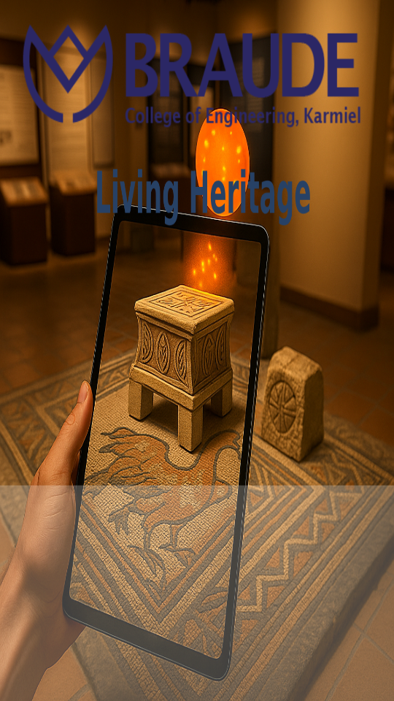

Capstone project - phase B

25-2-D-13
Supervisor: Dr. Naomi Unkelos Shpigel
By: Abdallah Aburomi & Bashar Hosari
https://github.com/abdallah0100/LivingHeritage
Table of Contents
Abstract .................................................................................................................................. 3
- General Description .................................................................................................... 4
1.1 Summary of Motivation .....................................................................................4
1.2 Product Overview ............................................ …………………………………...5
- Engineering Process .................................................................................................. 5
2.1 Development Methodology ..............................................................................4
- System Implementation ............................................................................................. 6
3.1 Tools and Technologies ....................................................................................6
3.2 Artifact Implementations ..................................................................................7
3.2.1 Ancient Boat – VR Discovery Experience ………………………………... 7
3.2.2 Magdala Stone ...............................................................................................8
3.2.3 The Ancient Mosaic – AR Exploration and Restoration Experience...........10
- System Architecture ..................................................................................................12
- Technical Challenges and Problems .....................................................................13
5.1 AR Tracking Limitations ..................................................................................13
5.2 Performance Constraints ................................................................................13
5.3 Historical Accuracy vs. Experience...............................................................14
5.4 Client Availability and Communication Constraints …………………...….14
- Lessons Learned and Retrospective Evaluation ................................................14
- Evaluation Results – Questionnaire Analysis .....................................................15
  - Participant Background……………………………………………………….…15
  - System Usability Evaluation (SUS).......................................................15
  - General VR Experience Evaluation……………………………………………..…16
  - Artifact-Specific Educational and Engagement Evaluation…………..17
  - Summary of Evaluation Findings……………………………..……….…..18
- User Guide ....................................................................…….…………………………...18
8.1 The Ancient Mosaic ..........................................................................................25
8.2 The Magdala Stone............................................................................................25
8.3 The Ancient Boat................................................................................................25
- Maintenance Guide …………………………..…………………...………………………26
9.1 System Environment and Dependencies ....................................................26
9.2 Deployment and Execution.............................................................................27
9.3 Main Scripts…………………………………………………………………….28

References…………………………………………………………………………….34
- Appendix……………………………………………………………………………….37

Abstract
This project presents the design, implementation, and evaluation of an immersive AR/VR educational system developed for the Yigal Alon Museum, a cultural heritage site dedicated to preserving and presenting historical artifacts from the Sea of Galilee region. The system was designed to enhance visitor engagement and learning through interactive digital experiences that combine historical content with immersive technologies.
Phase B of the project focuses on the full implementation, technical validation, and evaluation of the proposed AR/VR system. Building upon the conceptual design and requirements defined in Phase A, this phase emphasizes system realization in Unity, architectural decisions, handling technical challenges, usability testing, and evaluation of educational and experiential outcomes. The chapter documents engineering decisions, implementation details, testing methodology, and lessons learned, providing a complete view of the system as a functional software product.
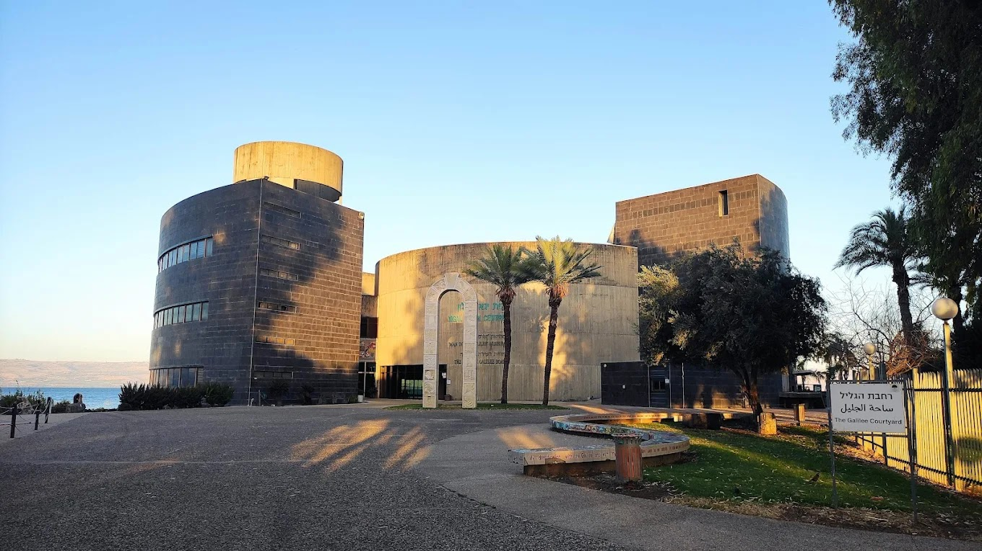
Figure 1 - Yigal Allon Center front view

1. General Description

1.1 Summary of Motivation
Museums increasingly seek interactive digital tools that enhance visitor engagement while preserving historical accuracy. According to Richards, cultural tourism is shifting toward experiences that emphasize participation, creativity, and meaningful engagement rather than passive consumption of information [1]. Similarly, Richards and Raymond describe creative tourism as an approach that enables visitors to actively develop knowledge and experiences through direct involvement [2].
Phase A of this project was grounded in research demonstrating that immersive technologies can enhance learning and engagement in cultural heritage contexts. As Moorhouse and Jung explain, augmented reality can enhance the learning experience in cultural heritage tourism by providing contextual and experiential interaction with content [3]. Building on these conceptual and educational foundations, Phase B focuses on transforming the proposed ideas into a robust and usable AR/VR application.
The motivation of this phase is to verify that AR/VR-based cultural heritage experiences can be implemented reliably, tested with real users, and evaluated using established usability principles. As defined by Nielsen, usability engineering emphasizes effectiveness, efficiency, and user satisfaction as key evaluation criteria for interactive systems [4]. In addition, Xu et al. highlight the importance of evaluating user retention and engagement in mobile AR learning environments [5].
1.2 Product Overview
The project is an interactive application designed to enhance the museum visiting experience through the integration of Augmented Reality (AR) and Virtual Reality (VR) technologies. Augmented reality has been shown to add value to tourism experiences by enhancing interpretation, visualization, and visitor engagement [6], while experiential learning supported by immersive technologies can significantly improve understanding in cultural heritage contexts [3].
As defined in Phase A, the system focuses on three key findings: the Magdala Stone, the ancient boat, and the ancient mosaic. Gamification is applied to increase user motivation, engagement, and learning outcomes in cultural heritage settings [5], following architectural principles that emphasize modular design, narrative-driven interaction, and immersive visualization [7].
The ancient mosaic is explored through an AR-based restoration experience that overlays digital content onto the physical environment, supporting contextual and experiential learning [8]. In contrast, the Magdala Stone and the ancient boat are presented through immersive VR experiences that reconstruct historical environments. Across all experiences, the system applies creative tourism and participatory learning principles to encourage active engagement with historical content [9].

2. Engineering Process

2.1 Development Methodology
Phase B followed an iterative, implementation-oriented engineering process. Development was carried out in short cycles consisting of:
- Feature implementation
New functionalities were implemented incrementally, focusing on one artifact or interaction at a time to ensure correctness and clarity.
- Internal testing
Each implemented feature was tested to verify functionality, stability, and compatibility with existing system components.
- User feedback collection
Feedback was collected from test users to evaluate usability, interaction clarity, and learning effectiveness.
- Refinement and bug fixing
Based on testing results and feedback, issues were corrected, interactions were refined, and usability improvements were applied.
This approach ensured alignment with user-centered design principles while accommodating technical constraints discovered during implementation

3. System Implementation

3.1 Tools and Technologies
- Game Engine: Unity (AR Foundation / Vuforia)
- Target Platform: Android
- Programming Language: C#
- Assets: 3D models, audio narration, subtitles, UI prefabs
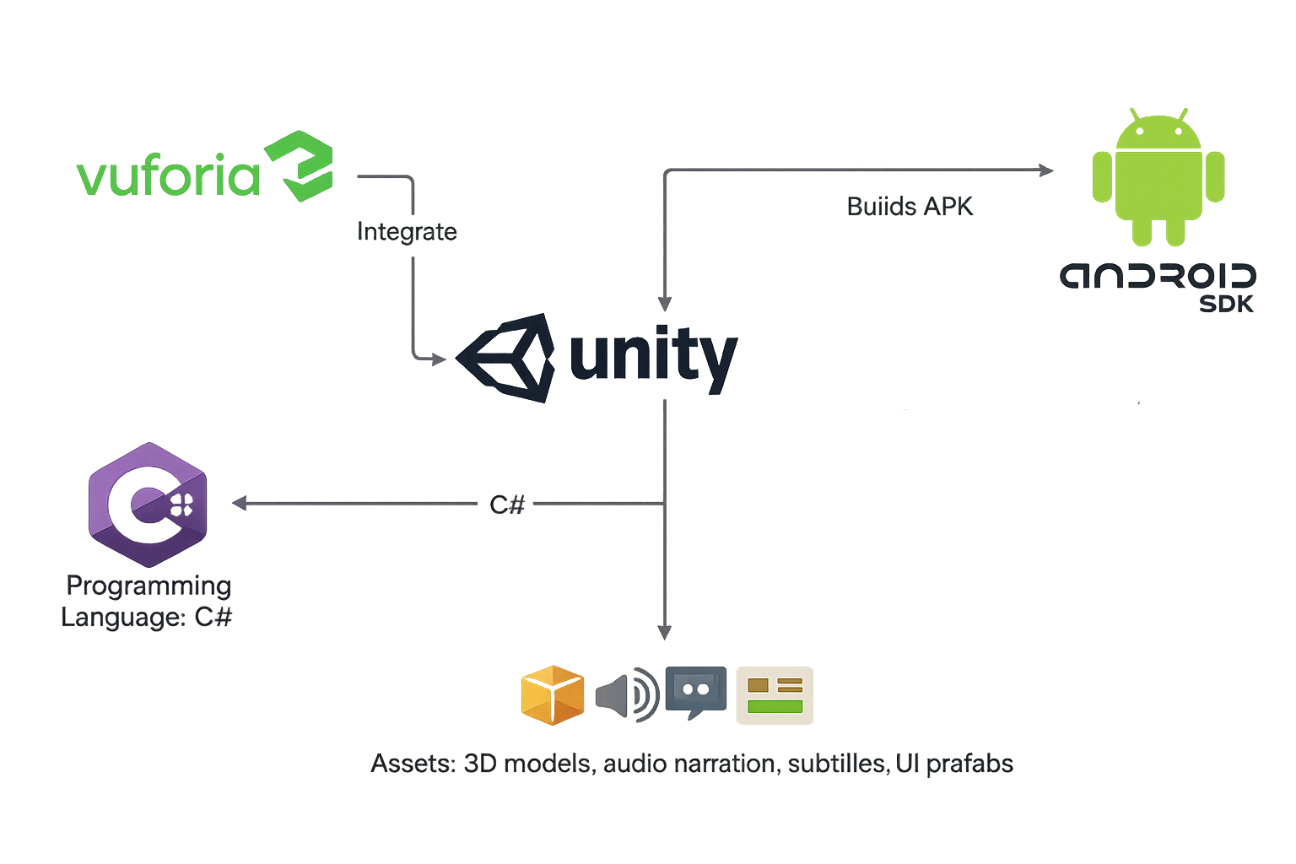
Figure 2 - Tools and technologies

3.2 Artifact Implementations

3.2.1 Ancient Boat – VR Discovery Experience
The ancient boat experience presents an interactive scene that recreates the historical discovery of the artifact. Figure 2 shows the VR shoreline environment in which the user is placed alongside virtual archaeologists, representing the documented event in which ancient nails were identified during a walk along the coast, leading to the excavation and discovery of the boat. This historical process is transformed into a gamified experience, allowing users to actively participate in the discovery rather than passively observe it. By combining storytelling with interactive challenges, as illustrated in Figure 2, the scene guides the user through the key moments of the discovery while reinforcing learning through engagement and achievement-based feedback.

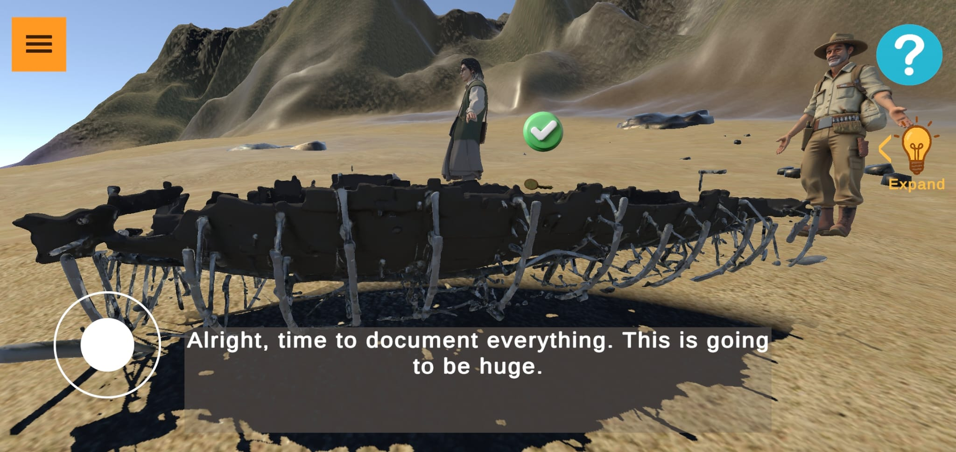
Figure 3 - Ancient Boat scene
The scene offers:
- A narrative-driven recreation of the boat’s discovery process.
- Interactive exploration of the beach environment.
- Discovery mechanics that simulate identifying clues, such as ancient nails.
- Gamified challenges that encourage user participation.
- Achievement and accomplishment badges that reward progress and successful interactions.
- An immersive VR experience designed to enhance historical understanding.

3.2.2 Magdala Stone
The Magdala Stone VR scene is set inside a reconstructed Magdala synagogue, where the user explores the symbolic elements associated with the stone through guided interaction. Figure 4 shows the initial scene presented to the user, including the welcome panel that introduces the experience and instructs the user to explore the symbolic elements within the temple environment. Each symbol depicted on the stone—such as the menorah, jar, rosette, and pillars—is spatially positioned within the virtual space. The user is required to interact with each symbol, triggering an informational panel that explains its historical and cultural significance.
Once all symbols have been explored, the Magdala Stone appears at the center of the room, enabling direct interaction and additional contextual explanations. The experience then transitions to a secondary scene where the user can freely examine the stone in detail, identify its symbols directly on the artifact, and complete a short quiz related to the content before choosing to continue exploration or end the experience.
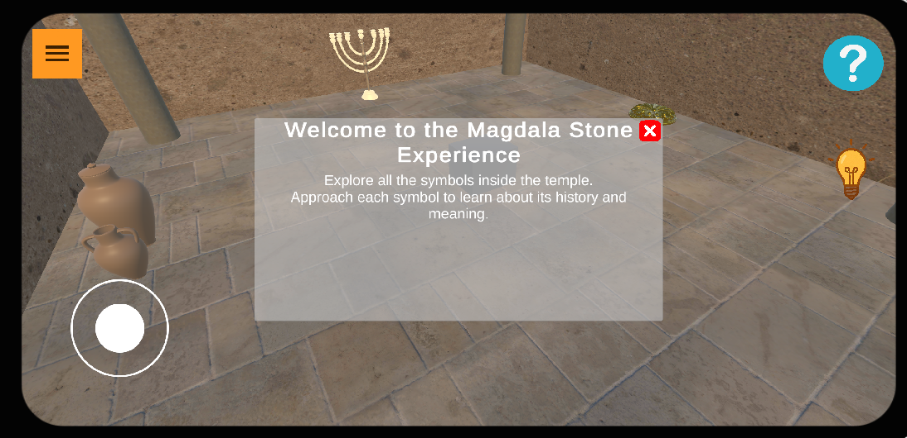
Figure 4 - Magdala stone scene
The scene offers:
- Interactive symbolic elements (menorah, jar, rosette, pillars)
- Informational panels providing historical explanations for each symbol
- Progress-based unlocking of the Magdala Stone interaction
- Free exploration scene for close examination of the stone
- Symbol discovery directly on the stone model
- Short educational quiz reinforcing learning outcomes
- User-controlled navigation to replay or complete the scene
3.2.3 The Ancient Mosaic – AR Exploration and Restoration Experience
The ancient mosaic experience is implemented as an augmented reality, gamified interaction that begins with the user scanning the physical mosaic using a mobile device. Figure 5 shows the AR view displayed on the device screen, where the physical mosaic is detected and augmented with interactive digital elements. Once detected, the user is invited to assist an archaeologist in uncovering the mosaic through an interactive cleaning and excavation process.
This hands-on experience allows users to actively engage with the artifact while learning about archaeological restoration techniques. As the experience progresses, an AR character appears and provides historical context and explanations about the mosaic. The scene concludes with the presentation of a holographic visualization, illustrating a predicted reconstruction of the fully excavated mosaic. In addition, the experience includes a puzzle-based mini-game that further reinforces learning through interaction.

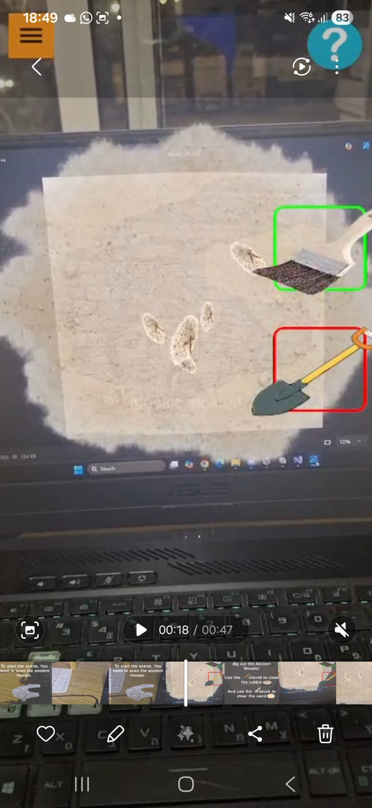
Figure 5 - The Ancient Mosaic
The scene offers:
- AR-based scanning and recognition of the physical mosaic.
- A gamified cleaning and excavation interaction.
- Interactive tools for digging and restoration simulation.
- An AR character that narrates the history and significance of the mosaic.
- A holographic reconstruction of the fully uncovered mosaic.
- A puzzle-solving mini-game to enhance engagement and understanding.

4. System Architecture
The final system architecture consists of the following layers:
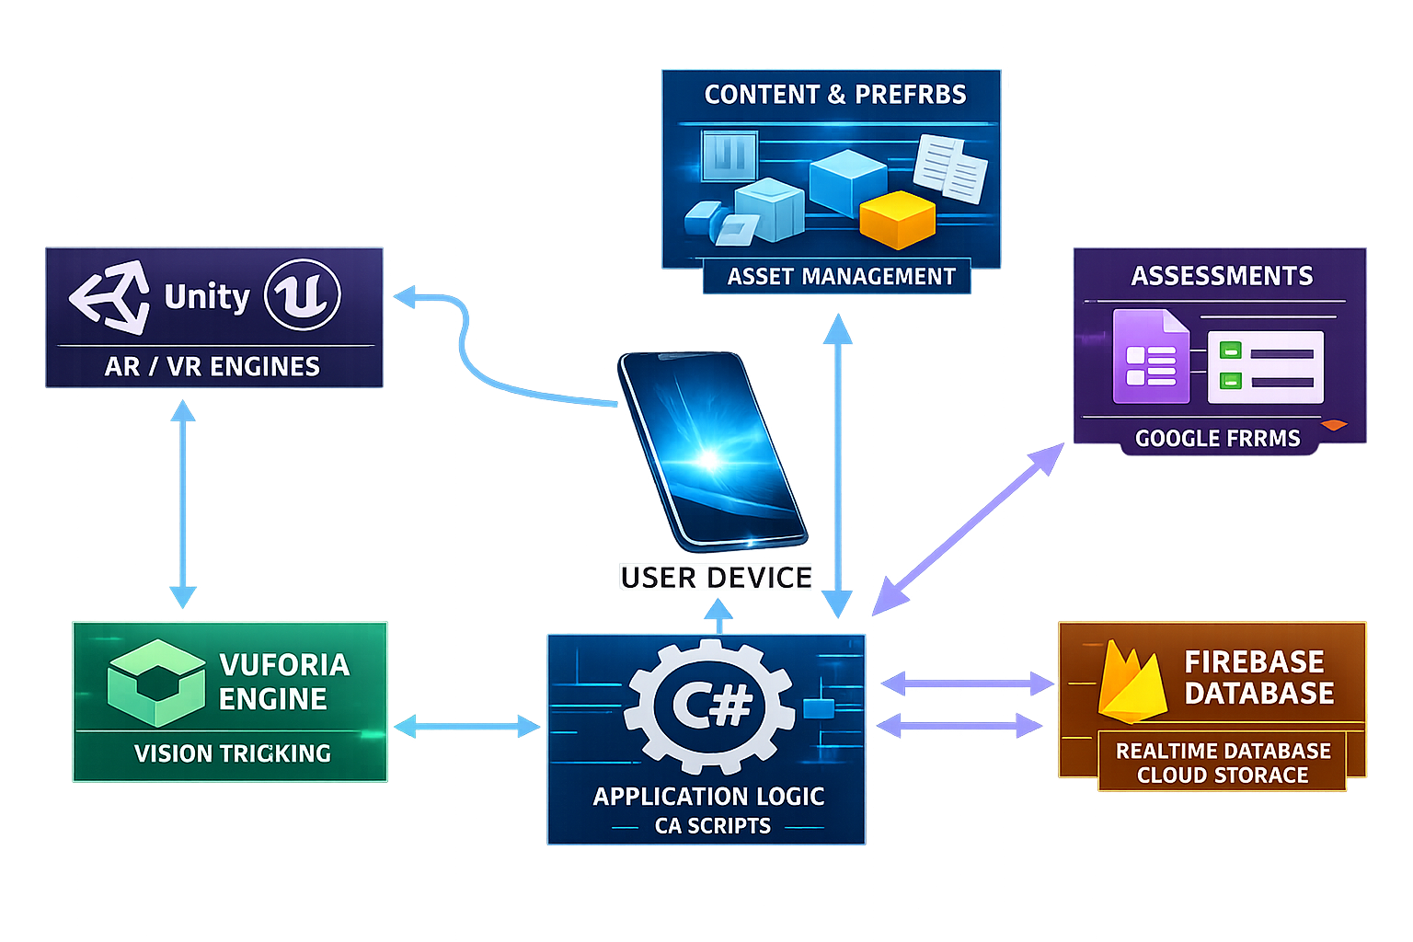
Figure 6 - High-level system architecture
The system developed in this project is based on a layered architecture designed to clearly separate responsibilities between the main components of the application. Figure 6 presents the system architecture at a high level, emphasizing the core components and the flow of data and interactions between them, without exposing internal classes or low-level implementation details.
As shown in Figure 6, the user device is positioned at the center of the architecture and serves as the primary interaction point for museum visitors. The application runs on a mobile device and communicates with the AR/VR engine (Unity), which is responsible for rendering virtual content and managing the immersive user experience.
The Vuforia Engine, also illustrated in Figure 6, is integrated into the system to handle image recognition and visual tracking. When a physical artifact is scanned, Vuforia identifies the target and triggers the corresponding AR content within the Unity environment.
The application logic layer, implemented in C#, controls the overall system behavior, including user interactions, mini-games, quizzes, progress tracking, and navigation between scenes. As depicted in Figure 6, this layer functions as the coordinator between the AR engine, the content assets, and the external cloud services.
The content and prefabs layer manages all digital assets, such as 3D models, audio narrations, subtitles, and user interface elements. These assets are dynamically loaded by the application logic according to user actions and the scanned artifact, as illustrated in Figure 6.
For data persistence and cloud services, the system integrates Firebase Realtime Database, which is used to store user progress, interaction data, and application state. In addition, Google Forms is used as an external assessment tool to collect structured user feedback and evaluation data, as shown in Figure 6.
Overall, the architecture presented in Figure 6 enables a clear separation of concerns, efficient communication between system components, and reliable operation within a real museum environment, while remaining flexible enough to support future extensions and additional artifacts.

5. Technical Challenges and Problems

5.1 AR Tracking Limitations
- Sensitivity to lighting conditions
- Recognition instability on reflective surfaces

5.2 Performance Constraints
- Optimization of 3D models
- Reducing scene load times

5.3 Historical Accuracy vs. Experience
- Avoiding presentation of speculative reconstructions as facts
- Explicitly labeling experiential content
5.4 Client Availability and Communication Constraints
- Limited response times from the museum staff required the team to efficiently utilize available feedback windows and make independent progress decisions between client interactions.

6. Lessons Learned and Retrospective Evaluation
The project was carried out using a structured and iterative engineering process; however, several practical challenges affected development decisions and workflow. A key lesson learned concerned stakeholder communication and availability. Although collaboration with museum staff was central to the project, limited availability led to delayed feedback on content accuracy, language requirements, and historical interpretation, requiring some decisions to be refined at later stages.
In retrospect, establishing a more formal communication framework—such as predefined review milestones—would have improved coordination and reduced uncertainty. From a technical perspective, this challenge emphasized the importance of system adaptability. The modular architecture enabled content and interaction updates without major code changes, which proved essential. Clearly distinguishing between historically verified information and experiential elements also helped maintain academic integrity while supporting user engagement.
Overall, despite communication constraints, the project provided valuable insights into stakeholder dependency, system flexibility, and risk management, which will inform future development efforts.

7. Evaluation Results – Questionnaire Analysis
The evaluation was conducted using a structured questionnaire with 15 participants, most of them aged 15–35. The participant group included both students and general users, with most participants having limited or no prior experience with VR/AR systems, while a minority reported previous exposure to immersive applications. All participants had basic familiarity with smartphones and digital interfaces, and several reported prior visits to museums.
The questionnaire consisted of Likert-scale questions (1–5), Yes/No questions, and short open-ended responses. The evaluation focused on usability (ease of use, navigation clarity, and interaction), educational impact (historical understanding), user engagement, and overall satisfaction across the VR and AR See here the Questionnaire.
7.1 Participant Background
The questionnaire began with background questions related to participants’ age group and their familiarity with museum-based or historical learning systems. This information was collected in order to ensure that the evaluation reflects a diverse range of user profiles, including both experienced users and first-time users of immersive learning technologies.
The responses indicate that participants represented multiple age groups and varying levels of prior exposure to museum-based learning systems. This diversity supports the validity of the evaluation results across different visitor types.

7.2 System Usability Evaluation (SUS)
System usability was evaluated using the System Usability Scale (SUS), a widely recognized standardized questionnaire for usability assessment. The SUS items examined ease of use, system consistency, user confidence, and the effort required to learn and operate the system.
Overall, the responses to the SUS questions were highly positive, with a SUS score of 70.8. Most participants agreed that the system was easy to use, well-integrated, and did not require extensive learning prior to effective interaction. These results indicate a high level of usability, which is particularly important in a museum environment where visitors may have limited time and no prior training.

7.3 General VR Experience Evaluation
The overall VR experience was evaluated through Likert-scale statements addressing learning effectiveness, navigation clarity, interaction intuitiveness, and engagement.
As shown in Figure 7, the majority of participants agreed or strongly agreed that the VR experience helped them better understand the historical content. This suggests that immersive visualization and interactive storytelling contributed positively to users’ comprehension of the cultural heritage material.
User responses related to interaction clarity and navigation ease, presented in Figure 8, indicate that participants generally found the virtual environment intuitive and easy to navigate. These findings demonstrate that the interaction design effectively supports orientation and task completion within the VR environment.
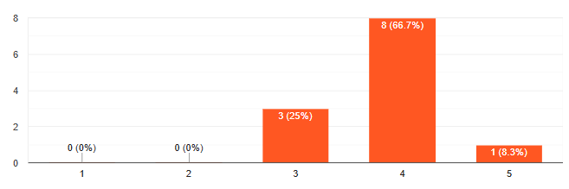 Figure 7 - User responses to the statement “The VR experience helped me understand the historical content better.”
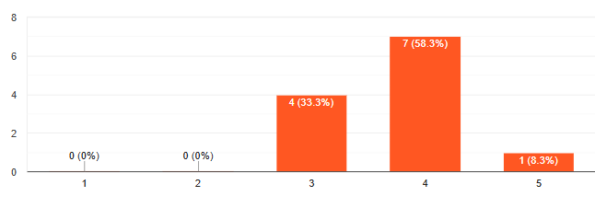
Figure 8 - User evaluation of interaction clarity with virtual artifacts.

7.4 Artifact-Specific Educational and Engagement Evaluation
To evaluate the educational and experiential impact of individual components, the questionnaire included dedicated sections for each interactive artifact: the Magdala Stone, Boat, and Mosaic games. These questions were informed by relevant academic literature and focused on learning effectiveness, clarity of information, engagement, and enjoyment.
Magdala Stone Game
Participants reported that the Magdala Stone game contributed to a better understanding of the cultural and historical context of the artifact. Most users also indicated that they felt engaged while interacting with the game and that the learning experience was more enjoyable than traditional learning methods.
Boat Game
Responses related to the Boat game showed positive evaluations regarding clarity of information, ease of use, and the quality of feedback provided during interaction. Participants indicated that the game effectively supported understanding of both the historical and technological aspects of the ancient boat.
Mosaic Game
The Mosaic game was evaluated in terms of cultural understanding, immersion, and focus. Most participants reported feeling focused and immersed during the activity and found the gameplay easy to understand. These findings align with flow-based learning principles and suggest that the game successfully sustained user engagement.

7.5 Summary of Evaluation Findings
Overall, the questionnaire results demonstrate that the system performs well across usability, educational effectiveness, engagement, and interaction clarity. The structured evaluation confirms that the design decisions made during development successfully support an immersive and informative museum experience. Although the evaluation scope was limited, the findings provide strong initial evidence of the system’s effectiveness and support future expansion and broader evaluation.

8. User Guide
This section provides a step-by-step guide describing how users interact with the application, from launching the system to completing the different museum experiences. The guide is intended for first-time users and does not require prior experience with VR or AR technologies.

Welcome Screen
The application opens with a welcome screen image 1 introducing the Yigal Alon Centre and the purpose of the VR experience. This screen provides a short description of how immersive digital technologies are used to enhance museum exploration. To begin the experience, the user presses the Start button
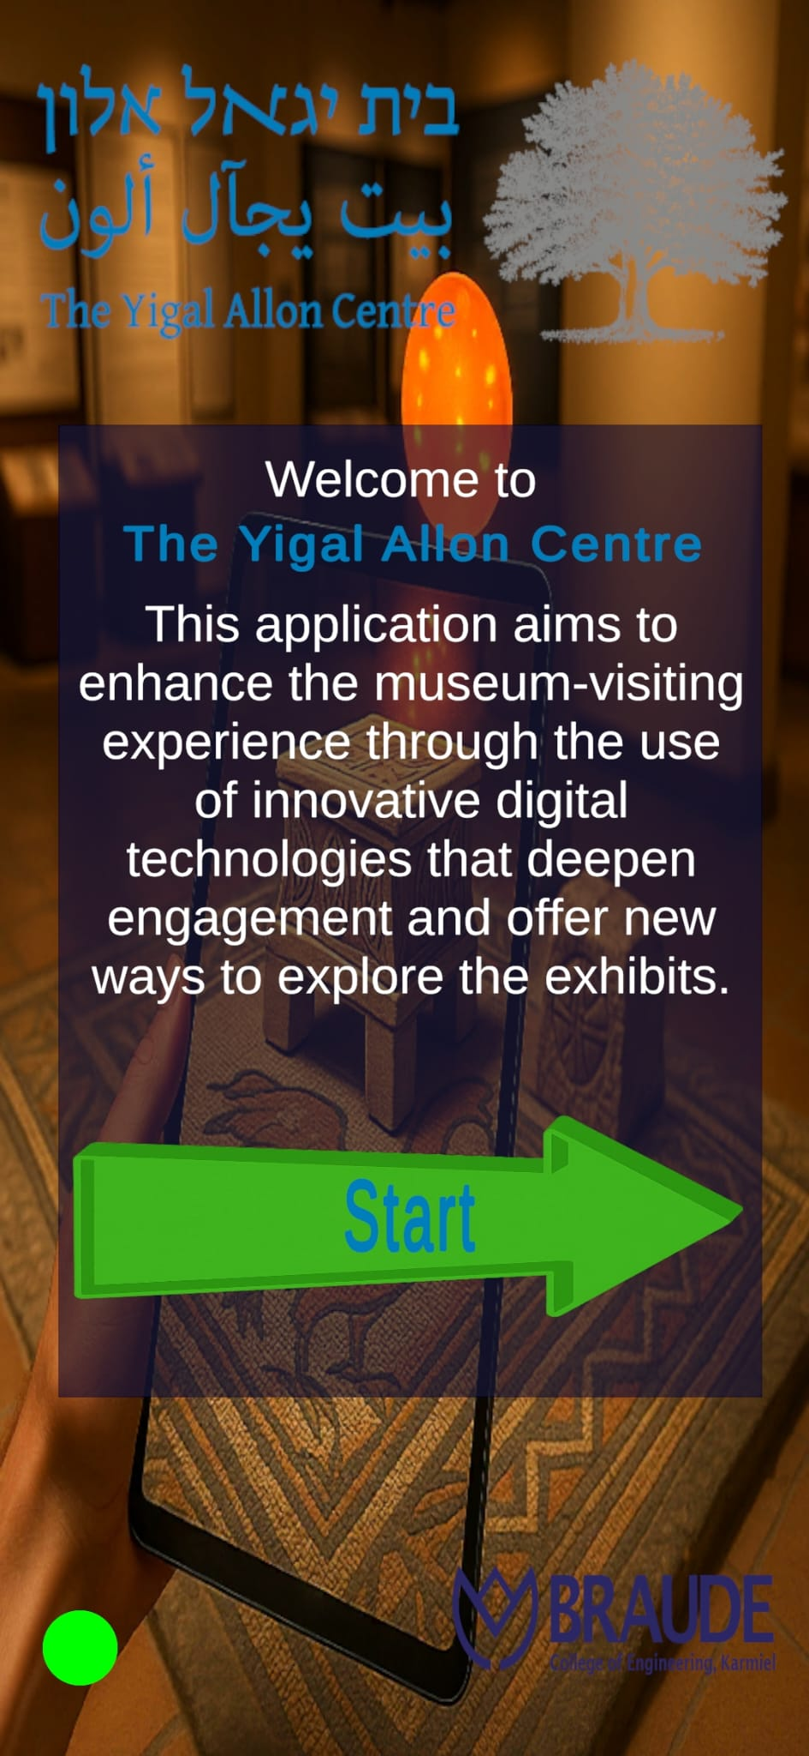
Image 1: Application Start

User Information Screen
After starting the application, the user is prompted to enter basic personal information, including name, age, gender, and prior experience with VR.
Once the required fields are completed, the user selects Continue to proceed to the exhibit selection screen. The user may also choose to skip this step and continue without providing personal details.

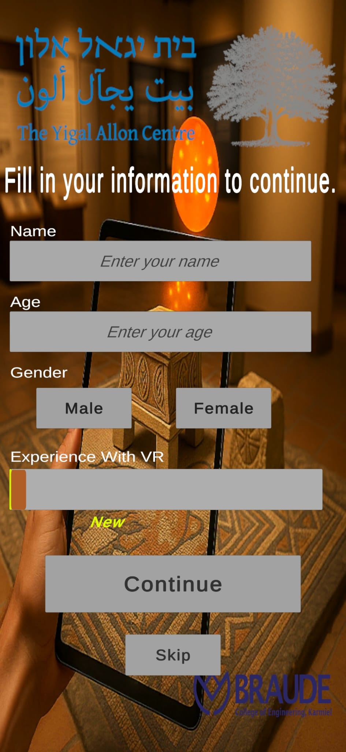
Image 2: User information input

Exhibit Selection
After completing the initial setup, the user reaches the exhibit selection screen. This screen presents the available museum experiences. In this example, the Magdala Stone exhibit is selected. The user can choose Overview & Start to receive a brief introduction and begin the experience, navigate using Previous and Next buttons to explore other exhibits, or select Fill a quick Quiz to provide optional feedback.
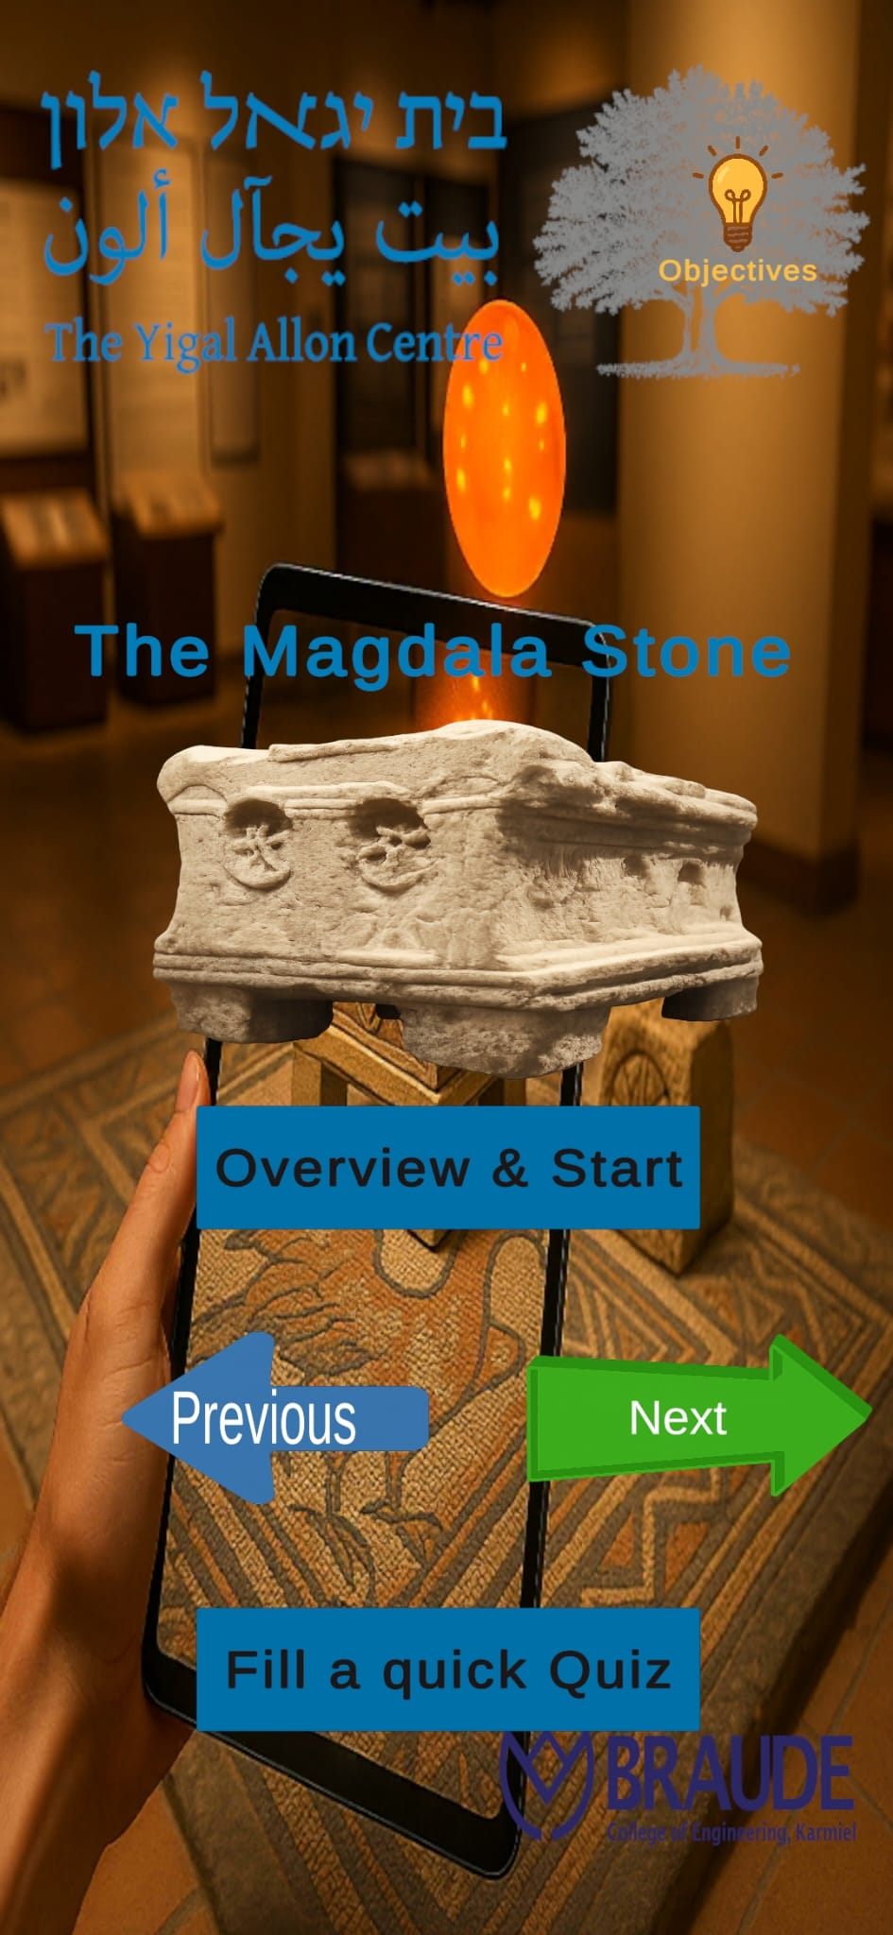
Image 3: Exhibit Selection

Exhibit Overview
Before starting the experience, the user is presented with an overview screen describing the historical background of the Ancient Boat and its discovery (image 4). This introduction provides context for the upcoming interaction. To begin the experience, the user selects Start.
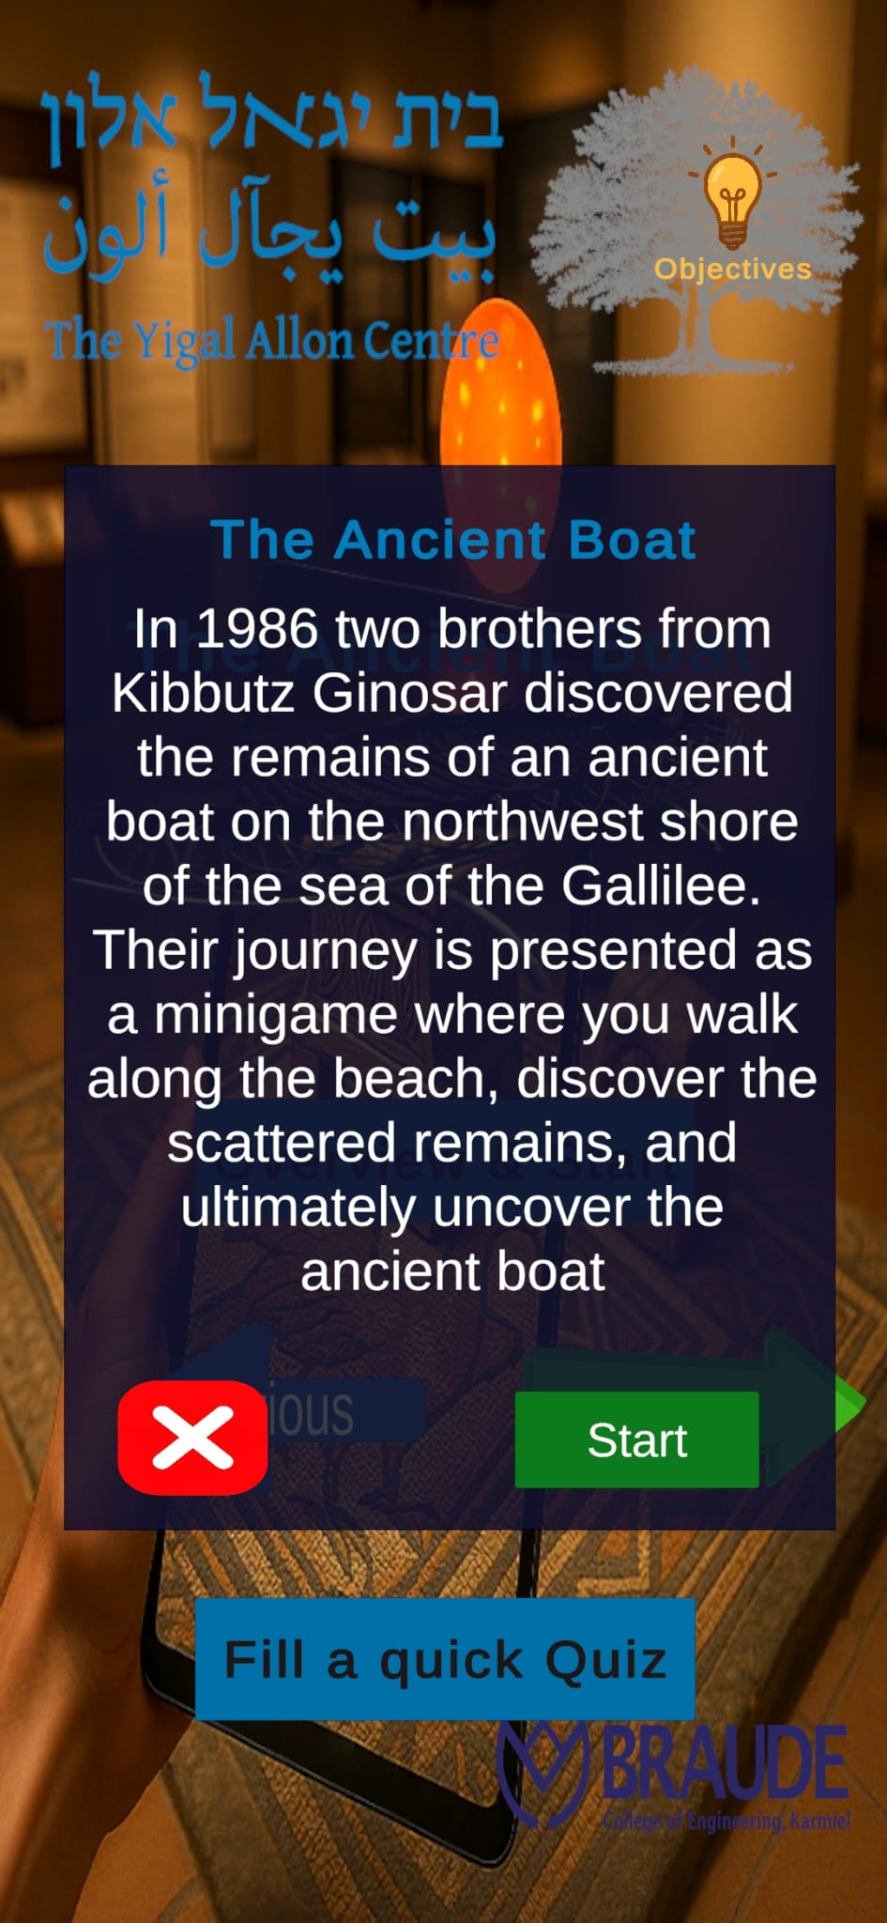
Image 4: Exhibit Description

Exploration Phase
Once the experience begins, the user enters a coastal virtual environment representing the historical setting of the Ancient Boat. A virtual guide introduces the scene through on-screen dialogue. The user explores the area using on-screen navigation controls, while the objective panel displays the current tasks and progress, such as finding specific items required to uncover the ancient boat.
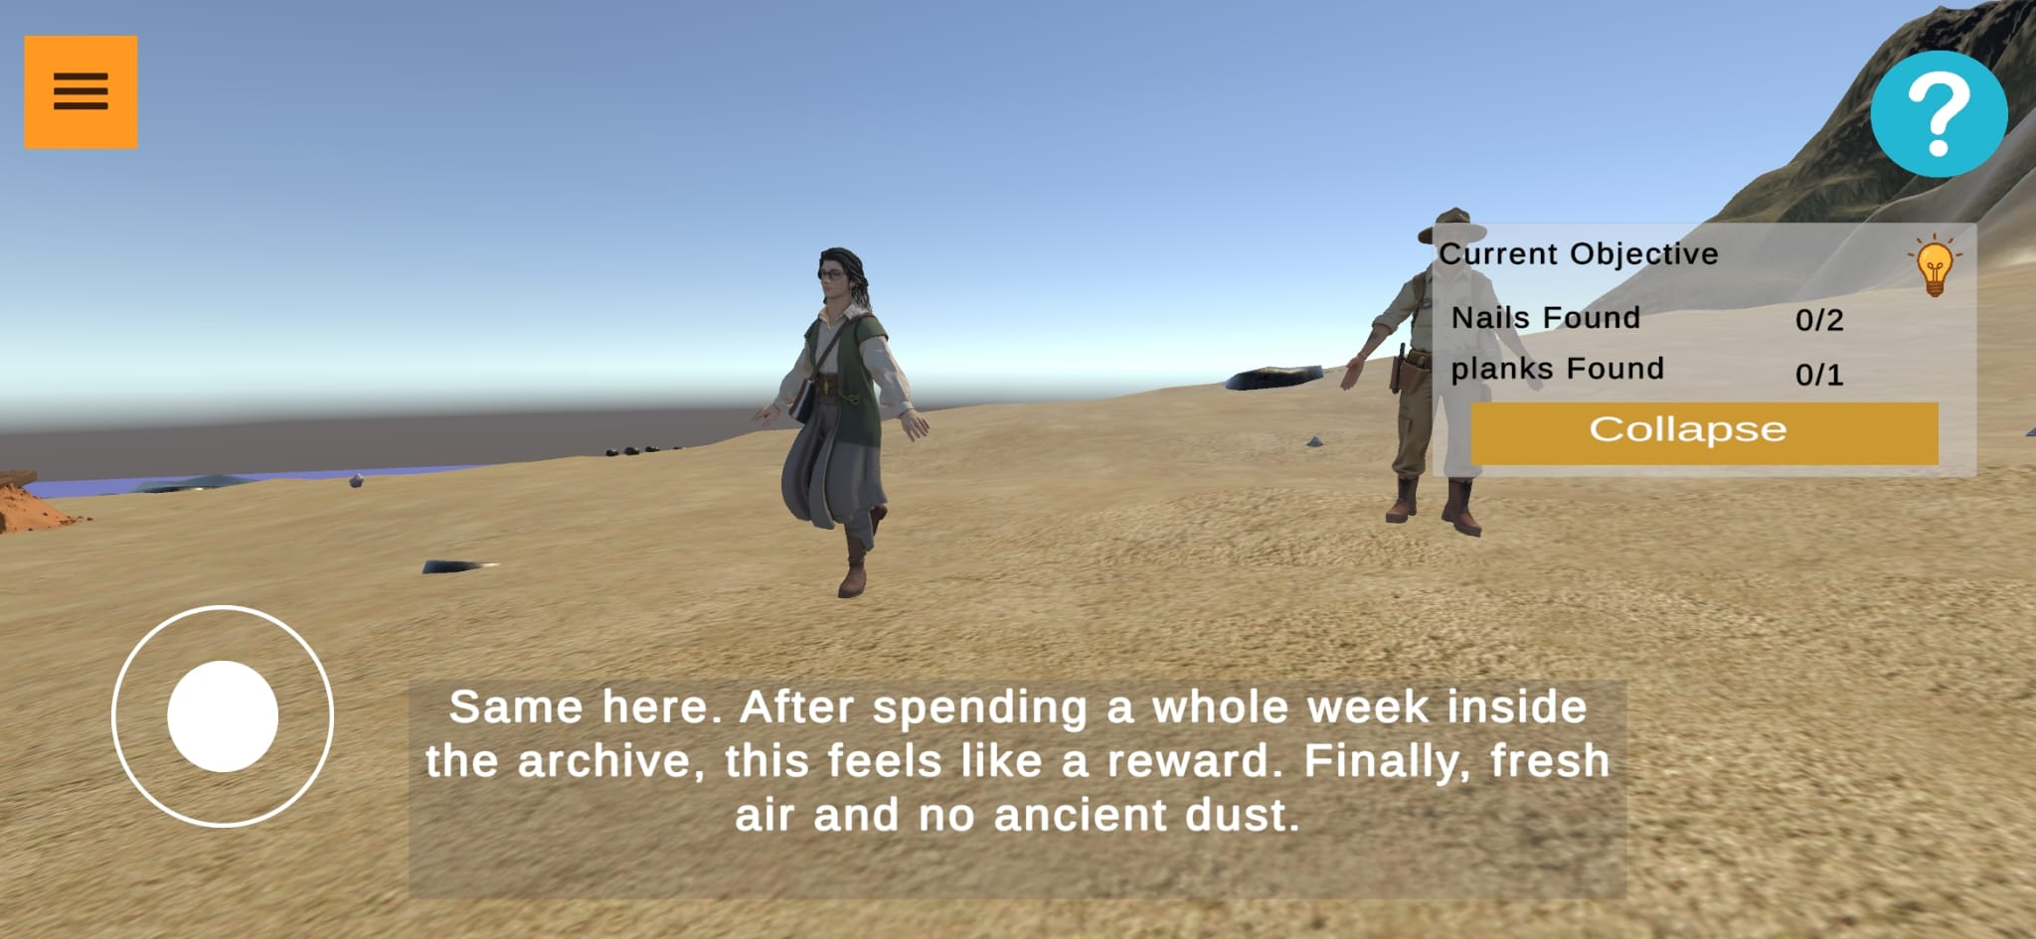
Image 5: Boat Scene with objectives

Pause Menu and Achievements Screen
During the experience, the user can open the pause menu to view progress and achievements. This screen displays completed objectives, earned badges, and performance records, such as completion time. From this menu, the user can return to the home screen, adjust audio settings, restart the experience, or select Resume Game to continue from the current point.
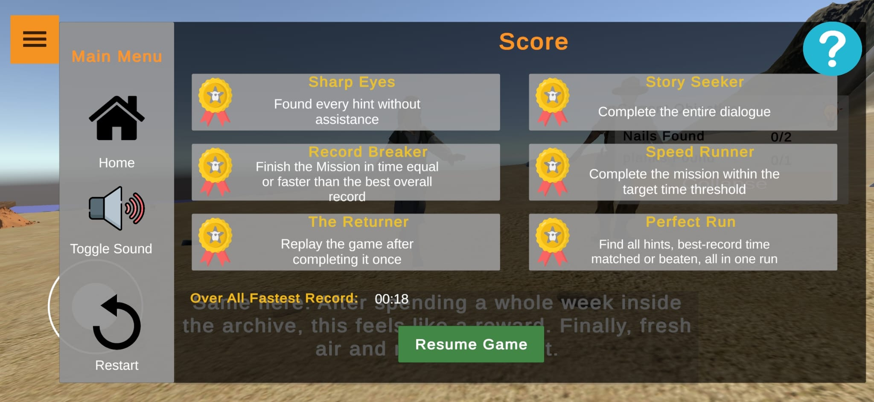
Image 6: Menu and Achievements

Magdala Stone – Symbol Discovery Scene
In this scene of the Magdala Stone experience, the user explores the environment to discover symbols associated with the artifact. When a symbol is found, an information panel appears, presenting visual and textual explanations of its historical and cultural meaning. The user can review the information and close the panel to continue searching for additional symbols.
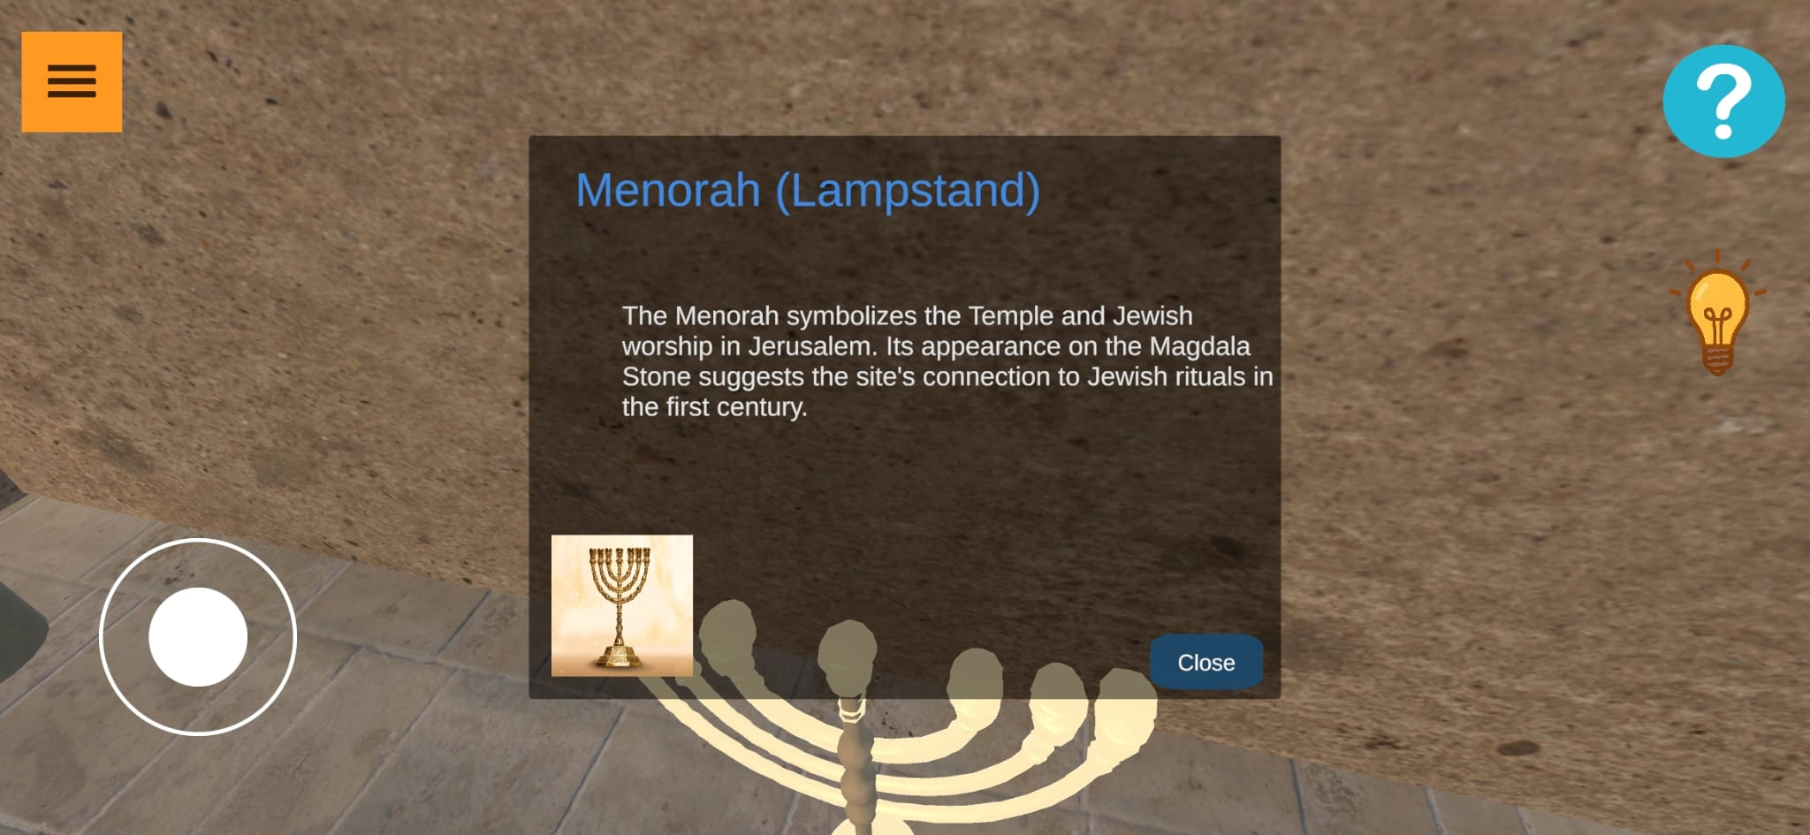
Image 7: Magdala Stone scene

Mosaic Scene – Cleaning Interaction and Reconstruction
In this scene, the user interacts directly with the mosaic surface. As shown in Image 8, the user uses on-screen tools to remove debris and reveal the hidden mosaic beneath. Once the cleaning process is completed, the mosaic transitions to its restored appearance, as shown in Image 9. This step visually demonstrates the transformation from the damaged state to the reconstructed historical form.

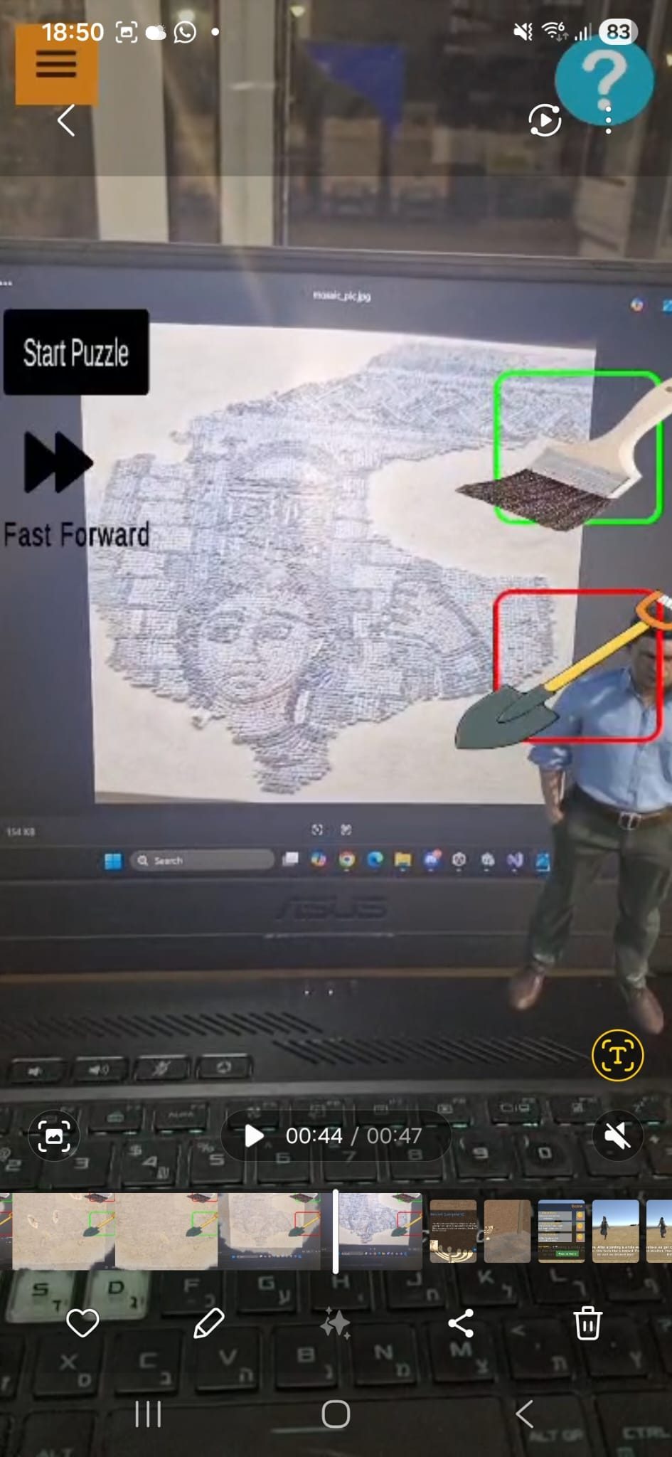
Image 8: Mosaic Scene cleaning Image 9: Mosaic post clean

8.1 The Ancient Mosaic
The user is required to scan the mosaic and then use the available tools to clean it from debris (Image 7). Once the cleaning process is completed, an interactive character appears and provides an explanation of the ancient mosaic (Image 8). After the explanation, a holographic visualization is presented, demonstrating how the mosaic is believed to have originally appeared. In addition, the user can participate in a puzzle mini-game related to the exhibit.
8.2 The Magdala Stone
The user begins by exploring the temple environment, searching for symbols and objects that are depicted on the Magdala Stone. Upon discovering an object, the user is presented with an explanation detailing its historical meaning (Image 7). After all relevant objects have been discovered, the ancient stone appears, allowing the user to examine it from all sides. In addition, the user can participate in a quiz related to the exhibit to reinforce learning and engagement.

8.3 The Ancient Boat
The user begins by exploring a coastal environment that simulates the historical setting in which the ancient boat was discovered. During exploration, the user searches for clues such as ancient nails, which trigger informational prompts explaining their significance. As the user uncovers each clue, they progress through the discovery process. Once all required elements are found, the ancient boat is revealed, allowing the user to examine it in detail. The experience also includes interactive challenges and achievement-based rewards.

9. Maintenance Guide
For maintainability and future scalability, the project was organized using a clear scene-based folder hierarchy (Figure 1). Each scene has its own directory under Assets/Scene/, containing all files relevant to that specific experience, including scripts, prefabs, models, audio, and images. This organization improves navigation, simplifies debugging, and allows modifications to be made to individual scenes without impacting others. In addition, special care was taken to document the code by adding comments to explain the purpose of each function, as well as inline comments at crucial logic points, making the system easier to understand, maintain, and extend by future developers.
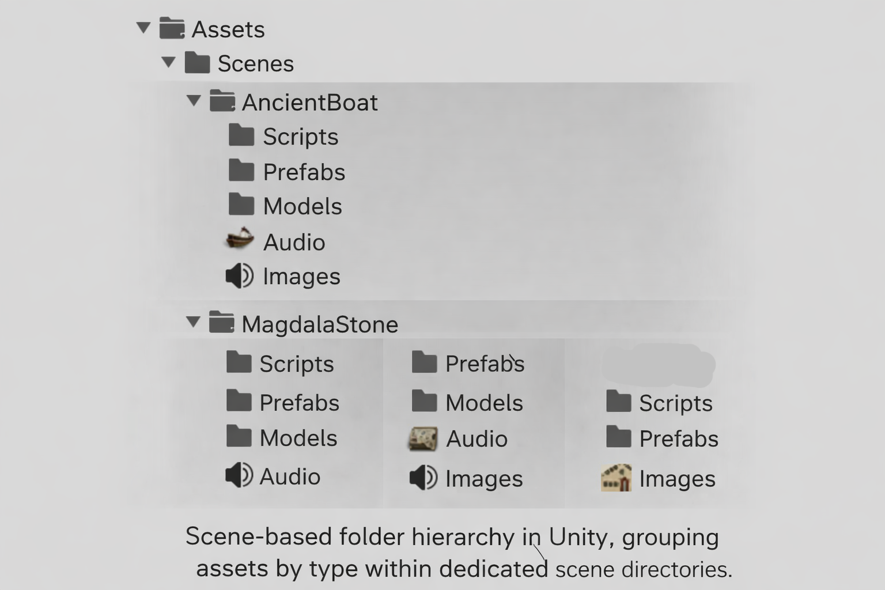
Figure 9: Showing the project hierarchy and file organization
9.1 System Environment and Dependencies
The system is implemented using the Unity game engine and is designed to run on VR/AR-capable devices. Maintenance activities assume familiarity with Unity and C# development.
Key dependencies include:
- Unity Engine (recommended LTS version for stability)
- XR Interaction Toolkit (for VR interaction handling)
- Vuforia Engine (for AR image recognition, when applicable)
- Firebase Realtime Database (optional, for progress tracking and data persistence)
- Standard Android SDK or VR platform support libraries

9.2 Deployment and Execution
The project can be deployed and executed using two supported methods, depending on whether the user is an end user or a developer.
Method 1: Installing via APK (End Users)
The application can be installed directly on an Android device using the provided APK file. The user transfers the APK to the device, enables installation from unknown sources if required, and installs the application normally. Once installed, the application can be launched directly from the device and used without any additional configuration.
Method 2: Building and Running via Unity (Developers)
For development and testing purposes, the project can be opened in the Unity Editor. After opening the project, the required dependencies and packages are automatically loaded. The developer selects the target platform (Android), connects a compatible device, and configures the build settings as required. The application is then deployed by using Unity’s Build and Run option, which builds the project and installs it directly on the connected device. This method allows rapid testing, debugging, and further development of the system.

9.3 Main scripts
9.3.1 HamburgerController
The HamburgerController script manages the in-game hamburger menu that appears consistently across all three artifact scenes (Magdala Stone, Ancient Boat, and Mosaic). This menu provides users with access to common actions, including pausing and resuming the experience, toggling sound on or off, restarting the current scene, and returning to the main artifact selection screen. The script controls the visibility of the menu panel, manages global audio state through the AudioListener, and handles scene navigation. By centralizing these shared controls in a single script, the system ensures consistent behavior and simplifies maintenance across all artifact experiences.
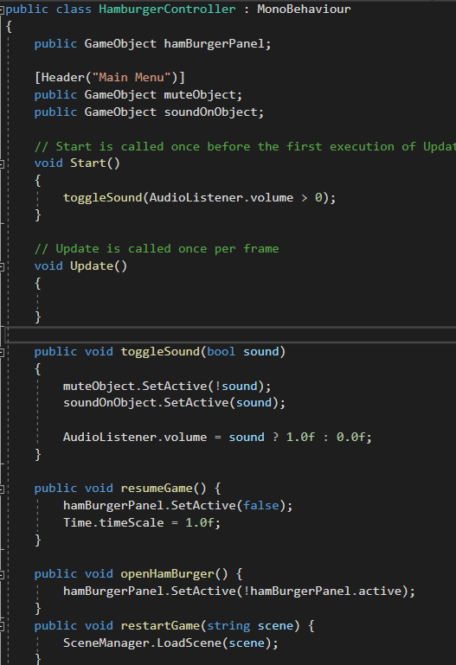
9.3.2 Ancient boat scripts
BeachMission script
The BeachMission script controls the gameplay flow of the Ancient Boat experience. The following functions represent the core logic and are the primary points of interest for maintenance and future extension.
9.3.2.1 missionController()
Determines the current mission phase. The function controls the progression between searching for nails and searching for the plank, ensuring the correct task is active at each stage.
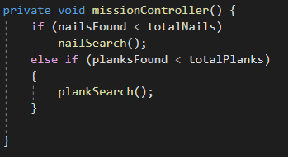
9.3.2.2 plankSearch()
Manages the plank discovery phase in a similar manner to the nail search. It spawns the plank, monitors user progress, and provides NPC assistance if required.
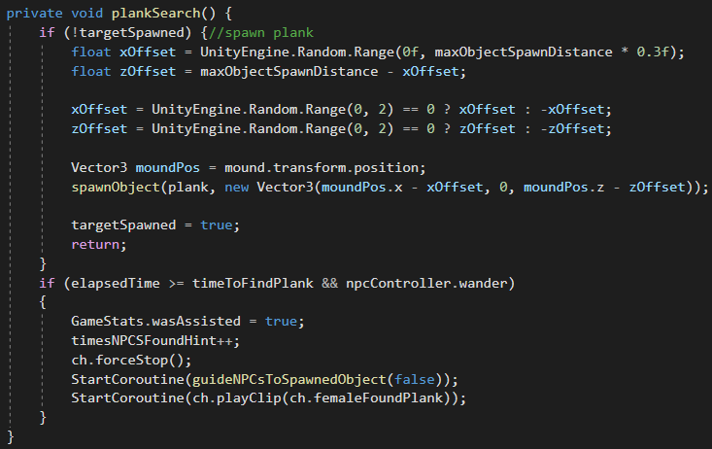

9.3.2.3 nailSearch()
Handles the logic for spawning nails and monitoring the time spent searching. If the user takes too long, the system triggers NPC hints and dialogue to guide the player toward the target.
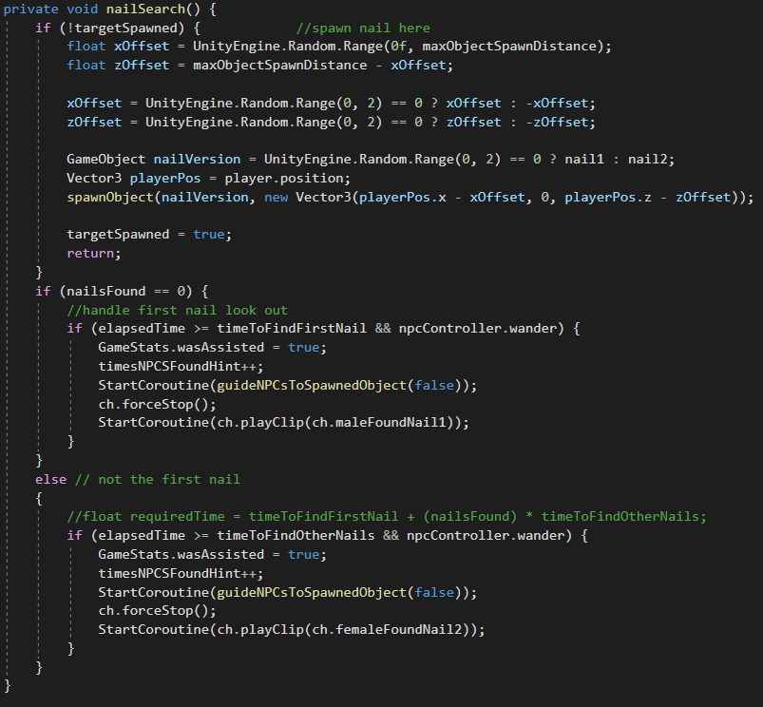
9.3.2.4 guideNPCsToSpawnedObject(bool)
Directs NPC characters toward the spawned object, serving as a visual hint system when the player requires assistance.
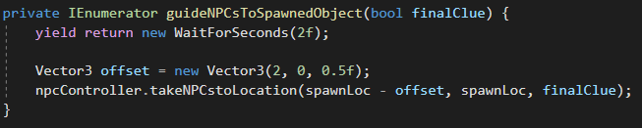

9.3.3 Magdala stone scripts

SymbolHotspot
The SymbolHotspot script controls interactive symbols within the Magdala Stone experience. It manages how symbol information panels are displayed, ensures correct progress tracking, and prevents overlapping or repeated interactions.
9.3.3.1 ShowFrom(SymbolTrigger data)
This is the main entry point of the script. It is called when the user interacts with a symbol. The function ensures that a shared information panel exists, updates the panel content using the provided symbol data (text, image, and audio), and applies “show once” logic when enabled. It also reports symbol discovery to the progress system and ensures that only one symbol panel can be open at a time.
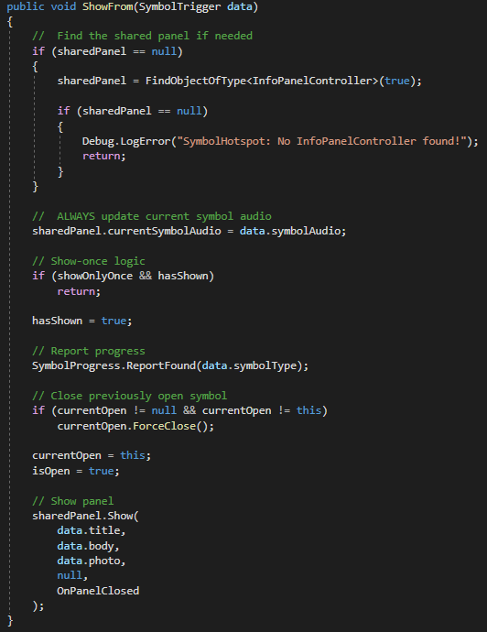

SymbolTrigger
The SymbolTrigger script detects player interaction with symbolic elements in the Magdala Stone experience and serves as the data provider for symbol-related information.
9.3.3.2 OnTriggerEnter(Collider other)
This function is triggered when the player enters the symbol’s collider. It first verifies that the interacting object is the player. Upon activation, the script plays the associated symbol audio, if available, and then forwards all relevant symbol data (title, descriptive text, image, symbol type, and audio reference) to the SymbolHotspot component. The hotspot is responsible for displaying the information panel and managing interaction state.
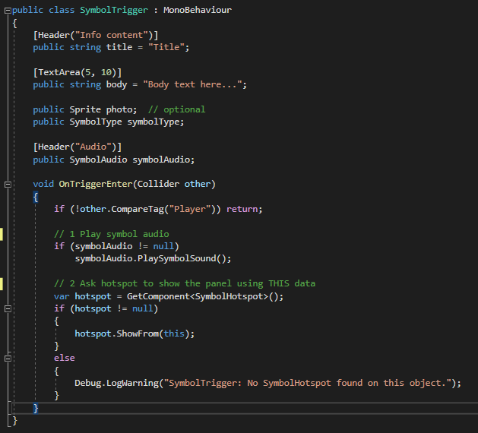

9.3.4 The Mosaic scripts

YigalMosaicHandler

The YigalMosaicHandler script controls the Mosaic AR flow after the Vuforia target is recognized. It manages the transition from scanning to interactive cleaning tasks (sand + rubble) and triggers the appearance of the virtual guide (Yigal) once the area is fully cleaned.

9.3.4.1 OnTargetFound()
Triggered when Vuforia detects the mosaic image target. This is the main entry point of the experience: it updates UI state, enables cleaning tools, shows status feedback, activates the sand overlay, and spawns rubble pieces on top of the target area. The hasTriggered flag prevents duplicate triggering.
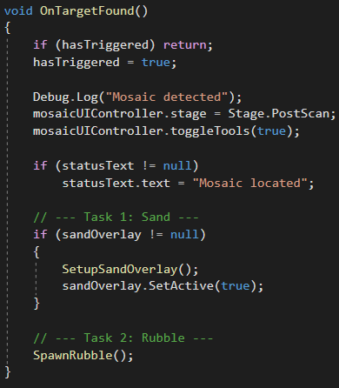

9.3.4.2 DelayAndSpawnYigal(float delay)
After a short delay, spawns the Yigal guide near the mosaic, faces him toward the camera, enables subtitles, and starts the narration via the YigalSpeech component.
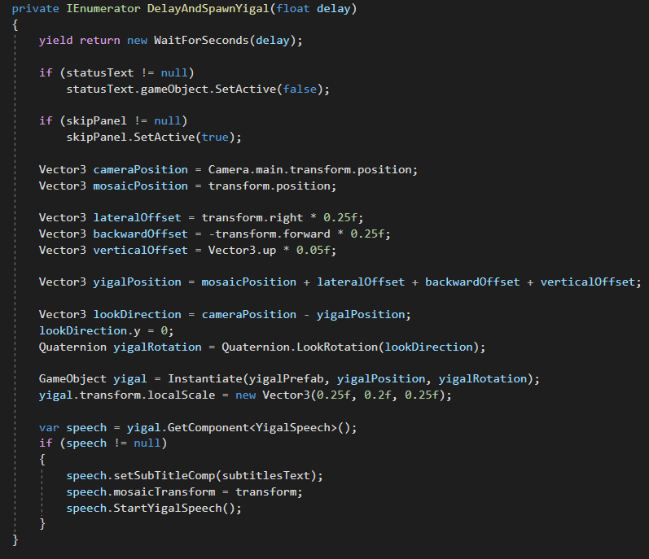

10. References
[1] Richards, G. (2018). Cultural tourism: A review of recent research and trends. Journal of Hospitality and Tourism Management, 36, 12–21.
[2] Richards, G., & Raymond, C. (2000). Creative tourism. ATLAS News, 23(8), 16–20.
[3] Moorhouse, N., & Jung, T. (2017). Augmented reality to enhance the learning experience in cultural heritage tourism: An experiential learning cycle perspective. Review of Tourism Research, 14(2), 1–15.
[4] Nielsen, J. (1993). Usability engineering. London, UK: Academic Press.
[5] Xu, N., Li, Y., Lin, J., Yu, L., & Liang, H. (2022). User retention of mobile augmented reality for cultural heritage learning. Proceedings of the IEEE International Symposium on Mixed and Augmented Reality (ISMAR-Adjunct), 381–386.
[6] Cranmer, E., tom Dieck, M. C., & Fountoulaki, P. (2020). Exploring the value of augmented reality for tourism. Tourism Review, 75(4), 1–15.
[7] Martusciello, F., Muccini, H., & Bucchiarone, A. (2025). A reference architecture for gamified cultural heritage applications. arXiv preprint arXiv:2501.01234.
[8] Sheidin, J., Ankava, L., Iyyon, N., & Unkelos-Shpigel, N. (2024). Augmented reality voyage in a maritime heritage museum. Computing, 106, 1–20.
[9] Richards, G., & Raymond, C. (2000). Creative tourism. ATLAS News, 23(8), 16–20.

11. Appendix
Questionnaire
1. What is your age group?
15–25
26–35
36–45
46–55
56–65
2. How familiar are you with historical or museum-based learning systems?
No experience
Some experience
Very experienced
3. System Usability Scale (SUS) Scale (1-5)
I think that I would like to use this system frequently
I found the system unnecessarily complex
I thought the system was easy to use
I think that I would need technical support to use this system
I found the various functions in this system well integrated
I thought there was too much inconsistency in the system
I imagine that most people would learn to use this system very quickly
I found the system cumbersome to use
I felt very confident using the system
I needed to learn many things before I could get going with this system
4. The VR experience helped me understand the historical content better
5. The interaction with virtual artifacts was clear and intuitive
6. The navigation inside the VR environment was easy to understand
7. The system provided a meaningful and engaging learning experience
8. Were there any parts of the VR experience that you found confusing or
unclear
9. What did you like most about the VR experience?
10. What would you improve or add to enhance the learning experience?

Yes or No:
11. The Magdala Stone game helped me better understand the cultural and historical content.
12. The visual and textual information presented in the Magdala Stone game was clear and understandable.
13. I felt engaged while interacting with the Magdala Stone game.
14. Learning through the Magdala Stone game was more enjoyable than traditional learning methods.

15.The Boat game helped me better understand the historical and technological context of the boat.
16. Learning through the Boat game was more engaging than traditional learning methods.
17. The system provided clear feedback while interacting with the Boat game.
18. It was easy to understand how to use the Boat game.
19. The information presented in the Boat game was clear and understandable.
20. The Mosaic game helped me better understand the cultural meaning of the mosaic.
21. I felt focused and immersed while interacting with the Mosaic game.
22. It was easy to understand how to play the Mosaic game.
23. The visual elements of the Mosaic game were clear and easy to understand.
24. Learning through the Mosaic game was more enjoyable than traditional learning methods.

